Overview

The *Bedrock Consortium* is a [Linux Foundation](http://linuxfoundation.org/) project that supports the operation the *Bedrock Business Utility (BBU)*, an independent self-governed public identity utility.

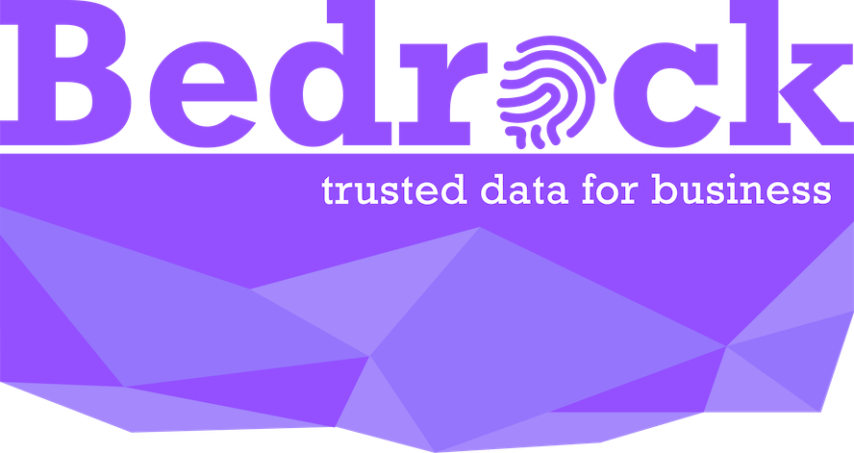

The BBU is intended to serve organizations that desire to participate in [digital trust ecosystems](https://bedrock-consortium.github.io/bbu-gf/gf_info/glossary/) and require an enterprise grade governance framework that will:

* Enforce permissioned-writes with contractual instruments that will conform to privacy regulations such as GDPR
* Maintain financial sustainability of the consortium members without the use of cryptographic tokens
* Establish a governing board so that no single organization owns the [Identity Utility Network](https://bedrock-consortium.github.io/bbu-gf/gf_info/glossary/)
* Require adherence to specified open standards and protocols

To meet these requirements, the BBU operates pursuant to its own governance framework. Consortium members pay annual membership fees and provide supporting infrastructure to maintain a sustainable permissioned identity utility that is structured as an enterprise safe-space and purpose built for trusted commerce. The consortium leverages an independent [Utility Service Provider](https://bedrock-consortium.github.io/bbu-gf/gf_info/glossary/) as a fee-based administrator for the delivery of a [DID Ledger](https://bedrock-consortium.github.io/bbu-gf/gf_info/glossary/) associated with a unique DID Root Namespace, did:bbu.

This document serves as the *constitution* for the BBU and represents the official BBU Governance Framework (BBU-GF).

The governing body responsible for the BBU-GF is the *Governing Board*.

# Consortium

## **Non-Profit Organization**[**¶**](https://bedrock-consortium.github.io/bbu-gf/gf_info/consortium/#non-profit-organization)

The **Bedrock Consortium** ("Consortium") is a project of the Linux Foundation and is backed by members that share a common interest in collaborating on the delivery of the infrastructure and governance necessary for a dedicated and trusted public identity utility based on decentralized identity technology. The utility is intended to reliably serve the verifiability of both physical and online digital identity interactions. The Consortium is focused on the governance of a dedicated decentralized identity utility for the exchange of trusted data. The Consortium represents a formal Trust Community consisting of participating members that adhere to the Bedrock Business Utility Governance Framework ("BBU-GF").

### **Legal Entity Structure**[**¶**](https://bedrock-consortium.github.io/bbu-gf/gf_info/consortium/#legal-entity-structure)

The [Linux Foundation](https://www.linuxfoundation.org/) (the “LF”) is dedicated to building sustainable ecosystems around open source projects to accelerate technology development and industry adoption. It provides support for open source communities through financial and intellectual resources, infrastructure, services, events, and training. The LF also provides a proven legal structure for the establishment of open source projects as non-profit legal entities for members.

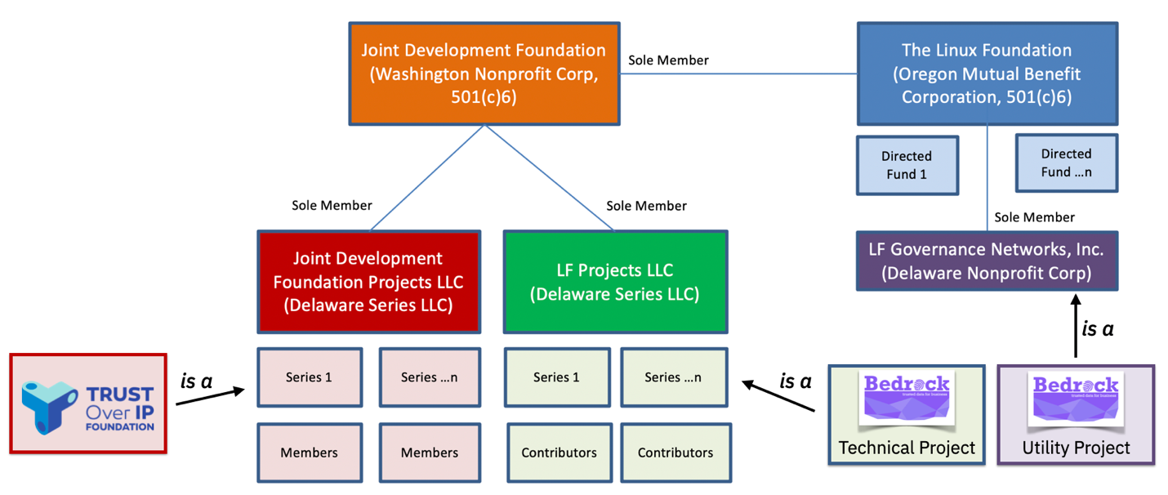

| Activity Type | Entity Name | Legal Structure | Purpose |
| --- | --- | --- | --- |
| Directed Fund | Bedrock Consortium Directed Fund | The Linux Foundation, (Oregon Mutual Benefit Corporation, 501(c)6) | The **Bedrock Consortium** is a directed fund of the Linux Foundation ("LF"). The Directed Fund uses a Project Participation Agreement that specifies funding commitments, policies, governance and customized utility utility agreements (with the utility agreements hosted by LF Governance Networks, Inc.). |
| Utility | Bedrock Business Utility | LF Governance Networks Inc, LLC (Delaware Non-Profit Corp) | The **Bedrock Business Utility ("BBU")** is an independent self-governed public identity utility enabled by the utility agreements. |
| Technical Project | Bedrock Technical Project | LF Projects LLC (Delaware Series LLC) | An LF affiliate entity that hosts open source projects such as the **Bedrock Technical Project**. Each open source project is associated with a Technical Charter setup as its own Series LLC under the LF Projects LLC. A project may require a CLA. |

### **Legal Entity Registration**[**¶**](https://bedrock-consortium.github.io/bbu-gf/gf_info/consortium/#legal-entity-registration)

The Bedrock Consortium (the “Directed Fund”), is a directed fund project of the LF. The Directed Fund serves two purposes:

1. Manage the operation and maintenance of the Bedrock Business Utility (“the Utility”).
2. Support for the Bedrock Technical Project (the “Technical Project”), an open source project, a LF Network Projects.

### **Membership Signing Requirements**[**¶**](https://bedrock-consortium.github.io/bbu-gf/gf_info/consortium/#membership-signing-requirements)

Participation in or use of a project entity may require the signing of one or more contractual instruments.

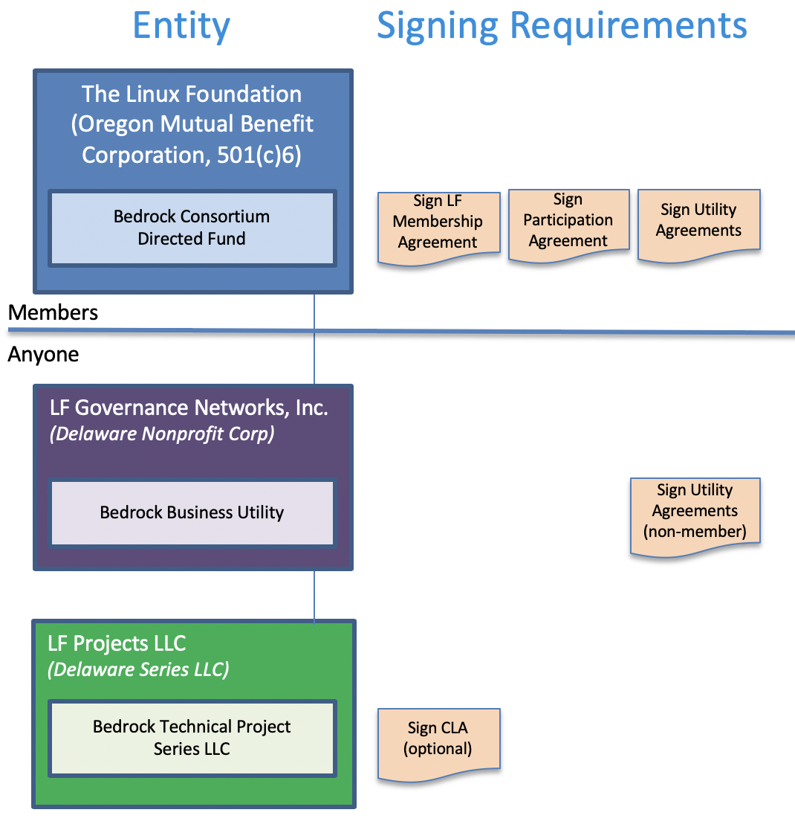

| Activity Type | Entity Name | Contractual Instruments |
| --- | --- | --- |
| Directed Fund | Bedrock Consortium Directed Fund | LF Membership Agreement, BBU Participation Agreement, and Utility Agreements. |
| Utility | Bedrock Business Utility | Utility Agreements, USP Contracts |
| Technical Project | Bedrock Technical Project | None |

The Bedrock Consortium Participation Agreement binds members to project funding commitments, policies, etc. It also puts forth a project charter that addresses the governance of directed fund and customized requirements for Utility Agreements.

For details pertaining to Utility Agreements, see "Exhibit B" of the Bedrock Consortium Charter (Exhibit B to the Bedrock Consortium Participation Agreement).

The Bedrock Technical Project does not require the signing of a Contributors License Agreement (CLA).

### **Consortium Name**[**¶**](https://bedrock-consortium.github.io/bbu-gf/gf_info/consortium/#consortium-name)

The name of the member-driven funding entity supporting the BBU is the Bedrock Consortium. The membership of the Bedrock Consortium shares a keen interest towards the establishment of trusted commerce. They believe in a set of fundamental privacy by design principles while mitigating financial and regulatory compliance risks.

The term “Bedrock” carries two pertinent meanings:

1. Gold accumulates at this solid foundational layer of the earth because water can't "wash it down" any further. The implication here is that our public identity utility ledger is the bedrock for business trust worldwide.
2. A “bedrock” principle is one that forms the basis for others principles. Our public identity utility ledger aims to provide the foundational principles for the exchange of trusted personal data.

## **Governing Board**[**¶**](https://bedrock-consortium.github.io/bbu-gf/gf_info/consortium/#governing-board)

The business of the Bedrock Consortium is overseen by a Governing Board. The Governing Board is comprised of representatives from members as outlined in the Bedrock Consortium’s Charter. See the Bedrock Consortium Participation Agreement.

## **Governance Framework of the BBU**

The Governing Board is responsible for establishing and maintaining the governance framework for the operation and administration of the Bedrock Business Utility ("BBU") . See the Bedrock Consortium Charter.

# Membership

The concepts outlined herein provide an informational synopsis for the operation of the Bedrock Business Utility and participation in the Bedrock Consortium. The executable  [BBU Participation Agreement](https://bedrock-consortium.github.io/bbu-gf/gf_legal/contracts/bbu_participation_agreement.docx) (the "Participation Agreement"), specifically Exhibit B and Exhibit C, supersedes this content.

## **Utility Infrastructure Requirements**[**¶**](https://bedrock-consortium.github.io/bbu-gf/gf_info/membership/#utility-infrastructure-requirements)

The Utility is an instance of a [ToIP Layer One Public Utility](https://github.com/hyperledger/aries-rfcs/tree/master/concepts/0289-toip-stack" \l "layer-one-public-utilities-for-decentralized-identifiers-dids) based on [Hyperledger Indy](https://www.hyperledger.org/projects/hyperledger-indy) ("Indy"). In order to establish an operational budget for the Utility, several infrastructure assumptions must be considered.

1. Budgetary requirements dictate how much revenue is required to keep the Utility sustainable.
2. Distributed ledger technologies, like Indy, leverage consensus algorithms that come with an optimal consensus threshold. This threshold value dictates the number of validator nodes required to operate the Utility. To meet the needs of a decentralized ledger, each validator node must be operated by an independent and unique participant. Therefore, a quantity requirement associated with one or more classes of members will be tied to the number of required validator nodes. Validator nodes may also be referred to as utility infrastructure nodes or Stewards from a historical [Sovrin Foundation](http://sovrin.org/) context.

A balance between budget requirements and technology limitations will define the number of validator nodes required to operate the Utility. Initially this will be set at twenty-five (25) utility infrastructure nodes. The set of active nodes on the network will be periodically pulled from a pool of available nodes.

### **Validator Node Pool**[**¶**](https://bedrock-consortium.github.io/bbu-gf/gf_info/membership/#validator-node-pool)

In order to efficiently operate the ledger associated with the Utility, a combination of production, test, and development environments are necessary. The Governing Board is responsible for defining the requirements associated with the validator pool. It is important to note that such Governing Board decisions will be influenced by both technical performance restrictions as well as budgetary demands.

| Framework Facet | Required Quantity | Comment |
| --- | --- | --- |
| Governing Board Seats | 7 | Minimum Governing Members. Governing Board seats can increase but MUST not exceed 15 |
| Minimum Production Pool Size | 19 | Considers production and Governing Board factors. |
| Minimum Test Pool Size | 3 | Ledger used by Utility Service Provider and Technical Project contributors. |
| Minimum Development Pool Size | 3 | Ledger used by Utility Service Provider and Technical Project contributors. |
| Minimum Total Pool Size | 25 | Considers requirements across all environments. |

### **Steward Population Dynamics**[**¶**](https://bedrock-consortium.github.io/bbu-gf/gf_info/membership/#steward-population-dynamics)

The number of Board of Director seats SHOULD be consistent as the population of Stewards (Governing and Operational Members) increases.

| Board of Director Seats | Required Stewards | BoD% |
| --- | --- | --- |
| 7 | 25 | 0.28 |
| 9 | 36 | 0.25 |
| 11 | 44 | 0.25 |
| 13 | 52 | 0.25 |
| 15 | 60 | 0.25 |

The Governing Board maintains a **FIFO Waiting List** of Operational Members that have maintained consistent membership. Position on the waiting list is based upon date of membership of the Operational Member. This list shall be used to offer new Governing Board seats upon availability due to attrition or growth.

## **Membership Types**[**¶**](https://bedrock-consortium.github.io/bbu-gf/gf_info/membership/#membership-types)

Building on our [Glossary](https://bedrock-consortium.github.io/bbu-gf/gf_info/glossary/), participants in the Consortium are referred to as Trust Community Members. These business entities agreed to participate in the Trust Community known as the Bedrock Consortium. Participation in the Consortium is possible via formal legal contracts or membership agreements.

### **Annual Membership**[**¶**](https://bedrock-consortium.github.io/bbu-gf/gf_info/membership/#annual-membership)

Private sector entities (businesses) can join and renew membership on an annual basis under three possible membership types:

| Membership Type | Validator Node Hosting Required | Governing Body Participation Required | Authorized Endorser Privileges (Ledger Writes) |
| --- | --- | --- | --- |
| Governing Member | Yes | Yes - 1 Per Governing Body | Yes - Unlimited |
| Operational Member | Yes | Yes - 2 | Yes - Unlimited |
| Subscriber | No | No | Yes - Limited |

1. Governing Member:
   * **Description**: Members that are willing to contribute to the infrastructure, management, and financial needs of the Utility. Minimally, this requires the member to contribute a Validator Node to the operation of the Ledger.
   * **Ledger Roles**:
     1. Validator Node: Must host one or more utility infrastructure nodes as defined in Exhibit C of the Participation Agreement.
     2. Transaction Endorser: APPROVED for the endorsement for Transaction Author write requests.
   * **Restrictions**:
     1. Membership is limited to the number of Board of Director seats available.
     2. A FIFO waiting list is maintained by Governing Board to allow for new members to fill voids left by exiting members.
     3. Must sign the required Utility Agreements as set forth in the Participation Agreement.
     4. Utility Service Providers MAY NOT be a Governing Member.
     5. Utility Service Providers MAY NOT participate in the Finance Committee.
   * **Benefits**:
     1. A single representative on the Board of Directors.
     2. Appointment of representatives to any Committee within the Directed Fund.
     3. Approval, pending signed Utility Agreements, to act as a Transaction Endorser.
     4. Write Transactions as a Transaction Endorser as defined in Exhibit C of the Participation Agreement.
2. Operational Member
   * **Description**: Members that are willing to contribute to the infrastructure, management, and financial needs of the Network. Minimally, this requires the member to contribute a Validator Node to the operation of the Ledger.
   * **Ledger Roles**:
     1. Validator Node: Must host one or more utility infrastructure nodes as defined in Exhibit C of the Participation Agreement.
     2. Transaction Endorser: APPROVED for the endorsement for Transaction Author write requests.
   * **Restrictions**:
     1. Must sign the required Utility Agreements as set forth in the Participation Agreement.
     2. Membership is limited to the number of nodes required to maintain optimal consensus performance. The optimal limit here must take into consideration a balance with decentralization requirements. The Governing Board will annually determine the number of nodes required to meet both consensus, decentralization, and budgetary requirements.
   * **Benefits**:
     1. Appointment of representatives to any Committee within the Directed Fund.
     2. Approval, pending signed Utility Agreements, to act as a Transaction Endorser.
     3. Write Transactions as a Transaction Endorser as defined in Exhibit C of the Participation Agreement.
     4. Members with continuous participation, can reserve a position to be invited as a Governing Steward via a FIFO waiting list.
3. Subscriber
   * **Description**: Members that are willing to be responsible for the endorsement of transactions to the ledger.
   * **Ledger Roles**:
     1. Transaction Endorser: APPROVED for the endorsement for Transaction Author write requests.
   * **Restrictions**:
     1. Must sign the required Utility Agreements as set forth in the Participation Agreement.
   * **Benefits**:
     1. Appointment of representatives to any Committee within the Directed Fund.
     2. Approval, pending signed Utility Agreements, to act as a Transaction Endorser.
     3. Write Transactions as a Transaction Endorser as defined in Exhibit C of the Participation Agreement.

### **Non-Membership Roles**[**¶**](https://bedrock-consortium.github.io/bbu-gf/gf_info/membership/#non-membership-roles)

1. Transaction Author
   * **Description**: Any entity (member or non-member) that is the submitter of a write transaction. **Ledger Roles**:
     1. Transaction Author: Interacts with a Transaction Endorser for the processing of write requests.
   * **Restrictions**:
     1. Only the transaction types outlined in the Utilities [ledger access policies](https://bedrock-consortium.github.io/bbu-gf/gf_controlled/ledger_access_policies/) and [ledger data policies](https://bedrock-consortium.github.io/bbu-gf/gf_info/gf_controlled/ledger_data_policies.md) are permitted.
     2. MUST sign the Utility Agreements as defined in the Participation Agreement.
   * **Benefits**:
     1. Ability to use ledger for decentralized identity interactions.
2. Contributors to the Technical Project. Contributions to the Technical Project are made pursuant to the terms of the Technical Charter for the Technical Project.